Diabetes

Report

2023-04-12

# Load data  
df <- read.csv('C:/Users/fvcds/Desktop/Project/diabetes.csv')

**Question#1(a)**

# Set seed and take a random sample of 25 observations  
set.seed(1234)  
sample <- df[sample(nrow(df), 25), ]

# Calculate mean and maximum glucose for sample and population  
pop_mean_glucose <- mean(df$Glucose)  
pop_max_glucose <- max(df$Glucose)  
  
sample_mean_glucose <- mean(sample$Glucose)  
sample_max_glucose <- max(sample$Glucose)  
  
# Create bar chart to compare mean and maximum glucose  
barplot(c(pop_mean_glucose, sample_mean_glucose, pop_max_glucose, sample_max_glucose),   
 names.arg = c('Population Mean', 'Sample Mean', 'Population Max', 'Sample Max'),   
 col = c('blue', 'red', 'blue', 'red'),   
 legend.text = 'Glucose',   
 ylim = c(0, 250))

**Output**

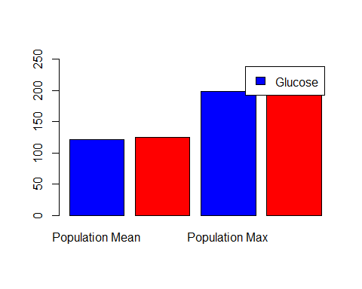

**Question#1 (b)**

# Find the 98th percentile of BMI for sample and population  
pop_98th_percentile_bmi <- quantile(df$BMI, 0.98)  
sample_98th_percentile_bmi <- quantile(sample$BMI, 0.98)  
  
# Create boxplot to compare 98th percentile of BMI  
boxplot(df$BMI, sample$BMI,   
 names = c('Population', 'Sample'),   
 main = 'BMI 98th Percentile',   
 col = c('blue', 'red'))

**Output**

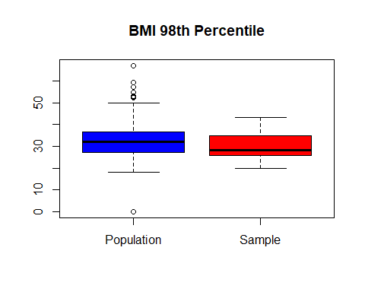

**Question#1 (c)**

# Create 500 bootstrap samples of 150 observations each and compare the statistics with the population statistics for BloodPressure  
n_samples <- 500  
sample_size <- 150  
  
bp_pop_mean <- mean(df$BloodPressure)  
bp_pop_sd <- sd(df$BloodPressure)  
bp_pop_25th_percentile <- quantile(df$BloodPressure, 0.25)  
bp_pop_75th_percentile <- quantile(df$BloodPressure, 0.75)  
  
bp_sample_means <- numeric(n_samples)  
bp_sample_sds <- numeric(n_samples)  
bp_sample_25th_percentiles <- numeric(n_samples)  
bp_sample_75th_percentiles <- numeric(n_samples)  
  
for (i in 1:n_samples) {  
 sample <- sample(df$BloodPressure, size = sample_size, replace = TRUE)  
 bp_sample_means[i] <- mean(sample)  
 bp_sample_sds[i] <- sd(sample)  
 bp_sample_25th_percentiles[i] <- quantile(sample, 0.25)  
 bp_sample_75th_percentiles[i] <- quantile(sample, 0.75)  
}

# Create plots to compare the statistics of the 500 bootstrap samples with the population statistics  
par(mfrow = c(2, 2))  
  
hist(bp_sample_means, main = 'Blood Pressure Mean', xlab = 'Mean', col = 'red')  
abline(v = bp_pop_mean, col = 'blue')  
  
hist(bp_sample_sds, main = 'Blood Pressure Standard Deviation', xlab = 'Standard Deviation', col = 'red')  
abline(v = bp_pop_sd, col = 'blue')  
  
hist(bp_sample_25th_percentiles, main = 'Blood Pressure 25th Percentile', xlab = '25th Percentile', col = 'red')  
abline(v = bp_pop_25th_percentile, col = 'blue')  
  
hist(bp_sample_75th_percentiles, main = 'Blood Pressure 75th Percentile', xlab = '75th Percentile', col = 'red')  
abline(v = bp_pop_75th_percentile, col = 'blue')

**Outputs**

